Artificial Intelligence in Agriculture Market Set to Reach $11.2 Billion by 2031, Driven by Labor Shortages and Rising Food Demand
The Artificial Intelligence in Agriculture Market is witnessing unprecedented expansion as farmers worldwide embrace smart farming technologies to address growing challenges. This rapidly evolving sector is projected to achieve a valuation of USD 11.2 Billion by 2031, representing a robust compound annual growth rate (CAGR) of 24.8% from 2024 to 2031.

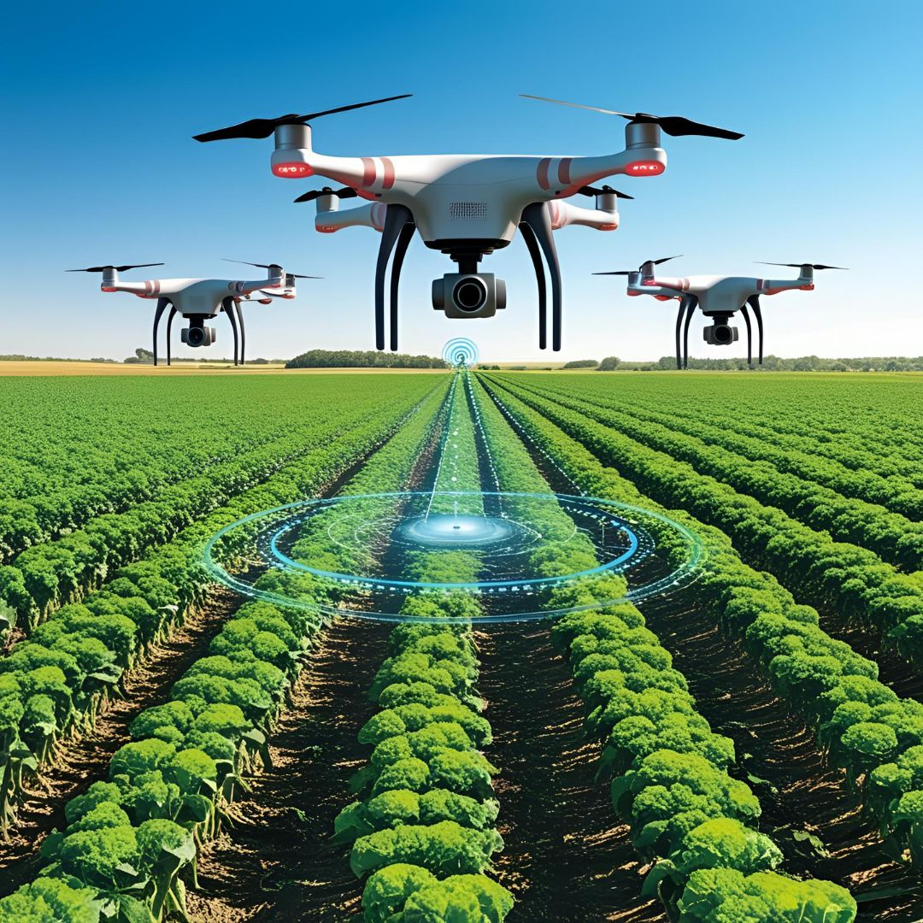

Get Free Sample Report PDF @ https://www.econmarketresearch.com/request-sample/EMR0086
Market Scope
AI-powered agricultural systems offer transformative capabilities across the entire farming lifecycle, from soil preparation to harvest management. These solutions include predictive analytics for crop yield optimization, autonomous machinery, drone-based monitoring, precision irrigation systems, and AI-enabled pest detection. The increasing focus on sustainable farming practices has accelerated adoption rates globally. With food security concerns mounting due to climate change and population growth, AI technologies are becoming essential tools rather than optional upgrades for forward-thinking agricultural operations.
Market Trends
The agricultural industry is rapidly evolving with the integration of machine learning, computer vision, and Internet of Things (IoT) technologies. Farm management software platforms increasingly feature AI capabilities as standard, allowing for comprehensive data analysis and automated decision-making. Additionally, there's a significant trend toward edge computing in agricultural AI applications, enabling real-time processing in remote field locations with limited connectivity. This allows farmers to make immediate decisions based on current conditions without relying on constant cloud connectivity. Major agricultural technology companies are investing heavily in developing specialized AI chips designed specifically for farming applications.
Market Analysis
Severe labor shortages in traditional farming regions are driving unprecedented demand for AI automation solutions. The global push for sustainable agriculture practices has positioned AI as a critical tool for resource optimization and environmental stewardship. Agricultural equipment manufacturers are increasingly incorporating AI capabilities as standard features rather than premium add-ons. Government initiatives promoting precision agriculture, particularly in developing regions, further stimulate market growth. The convergence of decreasing sensor costs, improving connectivity infrastructure in rural areas, and more accessible AI platforms is creating ideal conditions for continued market expansion across diverse farming operations of all sizes.
Segment Analysis
By Technology Type
Machine Learning and Computer Vision dominate the market with approximately 45-55% share. This segment leads because these technologies enable critical applications like crop monitoring, disease detection, and yield prediction. The ability to process vast amounts of visual data from fields provides actionable insights that were previously impossible to obtain at scale.
By Application
Precision Farming holds the largest market share (around 40-50%) due to its immediate impact on operational efficiency and yield improvements. This application integrates multiple AI technologies to optimize resource usage across various farming activities.
By Farm Size
Large Commercial Farms currently represent the primary adoption segment (approximately 60-70%) as they possess the capital resources needed for significant technology investments. However, the small and medium farm segment is experiencing the fastest growth rate as more affordable and scalable AI solutions enter the market, democratizing access to these technologies.
Supply Chain Disruptions and Technology Adoption Barriers Challenge AI Agriculture Market Growth
Global semiconductor shortages have severely impacted the agricultural AI market. The limited availability of chips essential for AI-enabled farm equipment has led to production delays and price increases of 15-30% for smart agricultural machinery. This has forced many farmers to postpone planned technology upgrades or seek alternatives. Additionally, persistent supply chain disruptions for specialized sensors and other components have extended delivery times for complete AI farming systems by 3-6 months in some regions, causing farmers to miss optimal implementation windows aligned with growing seasons.
Technology adoption barriers represent another significant challenge to market growth. The substantial initial investment required for comprehensive AI farming systems remains prohibitive for many small and medium-sized farms, with complete solutions often costing $50,000-$200,000 depending on farm size and complexity. Furthermore, limited digital literacy among traditional farming communities creates implementation challenges, with studies showing approximately 40-50% of farmers in developing regions lack the technical skills to fully utilize advanced AI systems without significant support. These factors combined could potentially reduce the projected market growth rate by 3-5% if not adequately addressed through financing options and improved training programs.
Key Regional Developments
North America
North America currently leads the agricultural AI market with approximately 35-40% share. This dominance stems from the region's advanced technological infrastructure, substantial R&D investments, and early adoption of precision farming techniques. The presence of major agricultural technology companies and supportive government policies promoting farm modernization further strengthens this position.
Europe
Europe holds the second-largest market position with its strong focus on sustainable farming practices and stringent environmental regulations. The European Union's Farm to Fork Strategy explicitly supports the adoption of digital and AI technologies to reduce chemical inputs while maintaining productivity, creating a favorable environment for AI solution providers.
Asia Pacific
The Asia Pacific region represents the fastest-growing market due to its large agricultural base undergoing rapid technological transformation. Countries like China, India, and Australia are making significant investments in agricultural modernization. Government initiatives addressing food security concerns through technology adoption are particularly driving growth in this region.
A Dynamic Ecosystem: Leading Players in the Agricultural AI Market
The agricultural AI market features diverse participants including established agricultural equipment manufacturers like John Deere and AGCO Corporation, who have integrated AI capabilities into their machinery lines. Technology giants Microsoft, IBM, and Google have developed specialized AI platforms for agricultural applications. Meanwhile, agricultural technology specialists such as Climate Corporation (Bayer), Farmers Edge, and Taranis focus exclusively on AI-driven farming solutions. Additionally, emerging startups like Prospera Technologies, Blue River Technology, and FarmWise are disrupting the market with innovative approaches to specific agricultural challenges. This blend of established players and innovative newcomers ensures continuous advancement in agricultural AI technologies.
Key Takeaways for the Artificial Intelligence in Agriculture Market Study
- The agricultural AI market is projected to reach USD 11.2 Billion by 2031, growing at an impressive CAGR of 24.8%.
- Severe labor shortages and increasing food demand due to population growth are primary market drivers.
- Machine Learning and Computer Vision technologies lead the market by enabling critical applications like disease detection and yield prediction.
- Precision Farming represents the largest application segment with approximately 40-50% market share.
- Supply chain disruptions and technology adoption barriers pose significant challenges to market growth.
- North America leads the market, while Asia Pacific demonstrates the fastest growth potential.
- Government initiatives promoting sustainable farming practices are accelerating AI adoption globally.
Prominent Key Players in the Agricultural AI Market
- John Deere
- IBM Corporation
- Microsoft Corporation
- Climate Corporation (Bayer)
- Farmers Edge
- Granular (Corteva)
- aWhere
- Prospera Technologies
- Taranis
- FarmWise
- Blue River Technology
- CropX
- Harvest CROO Robotics
- Trace Genomics
- AgEagle Aerial Systems
Recent Developments Accelerate Agricultural AI Innovation
In February 2024, John Deere expanded its AI capabilities through the acquisition of a leading computer vision company specializing in crop monitoring technology. This strategic move enhances Deere's ability to offer end-to-end autonomous farming solutions.
January 2024 saw Microsoft and a consortium of agricultural research institutions launch an open-source AI platform designed specifically for small-scale farmers in developing regions. This initiative aims to democratize access to AI farming technologies by providing affordable and simplified solutions tailored to local agricultural conditions.
Read This Research Report with Charts and Graphs @ https://www.econmarketresearch.com/industry-report/artificial-intelligence-in-agriculture-market/
About Us:
Econ Market Research, we are dedicated to delivering precise, actionable market intelligence that drives business success. Our team of expert analysts combines advanced data analytics with deep sector knowledge to provide comprehensive market insights. We specialize in custom research solutions, competitive analysis, and strategic forecasting across diverse industries. Our commitment to quality and accuracy has earned us the trust of Fortune companies, startups, and government agencies worldwide. Through innovative methodologies and rigorous analysis, we empower our clients to make informed decisions that shape their future growth and market position.
Contact Us:
Econ Market Research
sales@econmarketresearch.com

